COS20019 – Assignment 1B

Janaka Pruthuvi Vimukthi Muthunayake

Student ID: 104315180

Tutorial: Wednesday 06:30pm

**Objectives**

*1. Create a secure Virtual Private Cloud (VPC) with subnets, routing tables and security groups.*

*2. Control access to and from your VPC via an Internet Gateway.*

*3. Modify the provided PHP code to create a website that stores meta-data information about*

*photos uploaded to S3 in a MySQL database managed by Amazon RDS. The website should*

*enable the user to search for and display photos using meta-data.*

*4. Deploy and test your PHP web site on an Apache web server running on an EC2 virtual*

*machine instance.*

*5. Add an additional layer of security by applying a Network ACL to the public subnet that hosts*

*your web server.*

**1 Infrastructure**

* 1. **VPC (Virtual Private Cloud)**

Created a secure VPC with subnets, security groups, internet gateway. created two availability zones each with a private and public subnet with suitable CIDR as specified in the infrastructure above and associated public subnets with a public route table that routes to the Internet gateway.

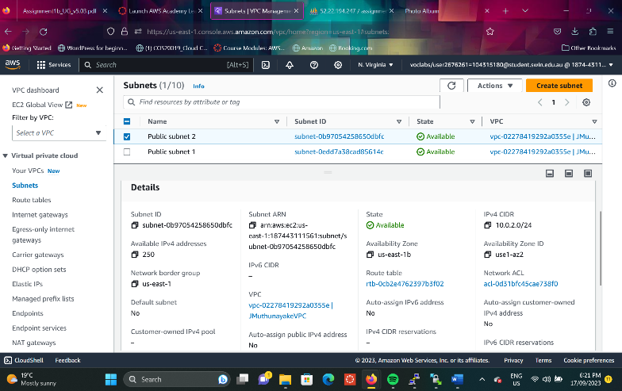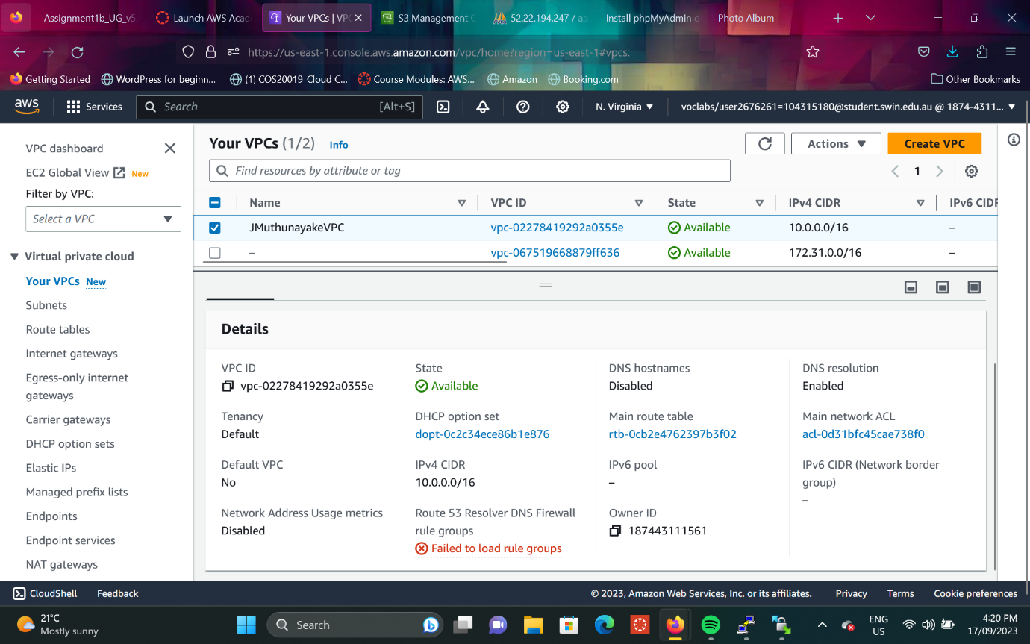*Created VPC*

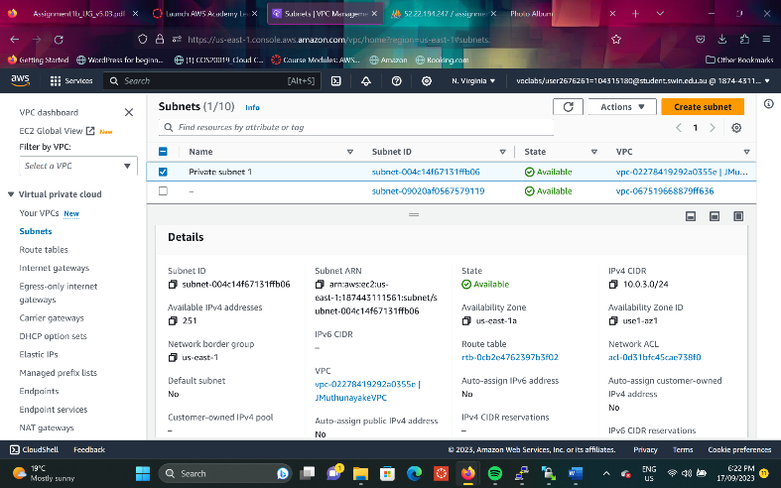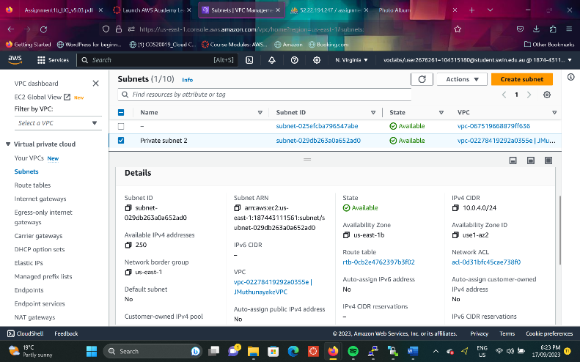*Public subnet 1 Public subnet 2*

*Private subnet 1 Private subnet 2*

*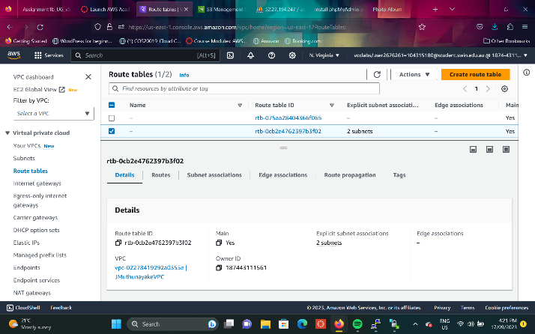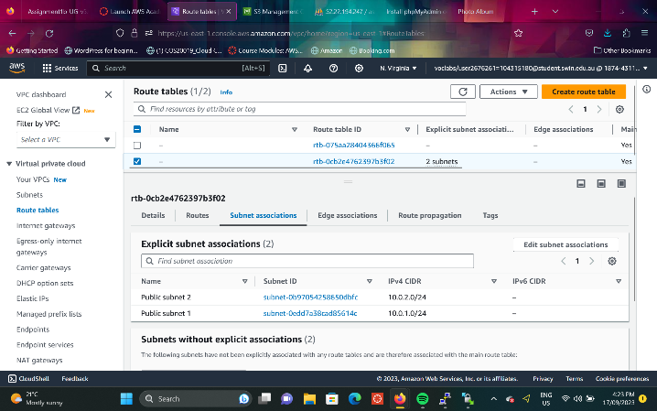Routing Table -> Subnet associates*

*Internet Gateway*

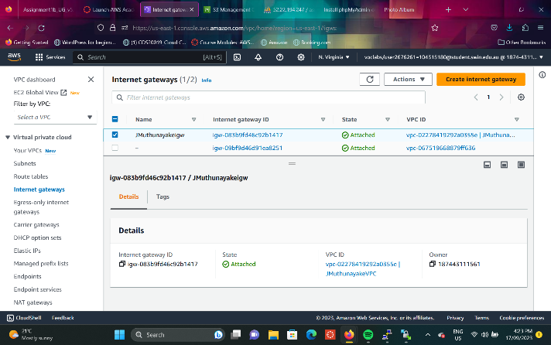

* 1. **Security Groups**

Crated the security groups according to the diagram.

*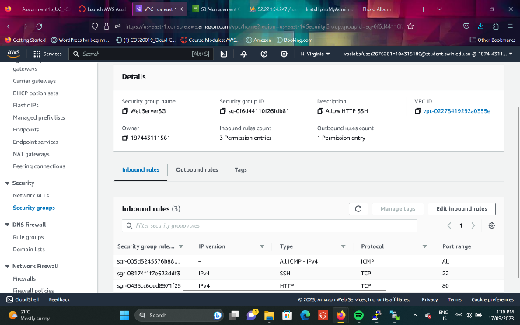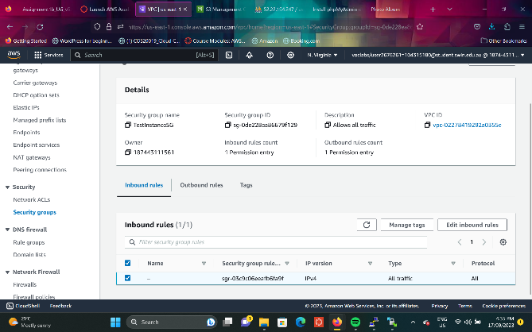Test Instance Security group Web Server Security group*

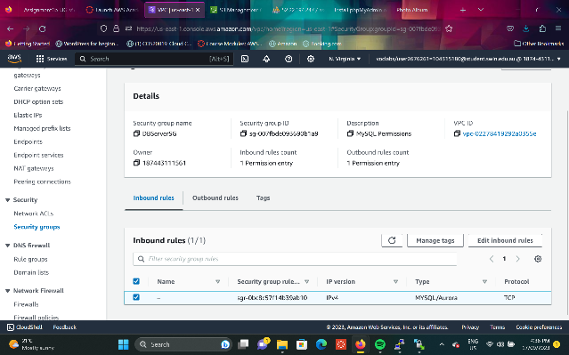

*DB Server Security group*

**1.3 EC2 Virtual Machine**